R.PRANUSHA

192111023

EXP:11) Demonstrate virtualization by Installing Type-2 Hypervisor in your device, create and configure VM image with a Host Operating system (Either Windows/Linux).

STEP 1: Create new virtualization

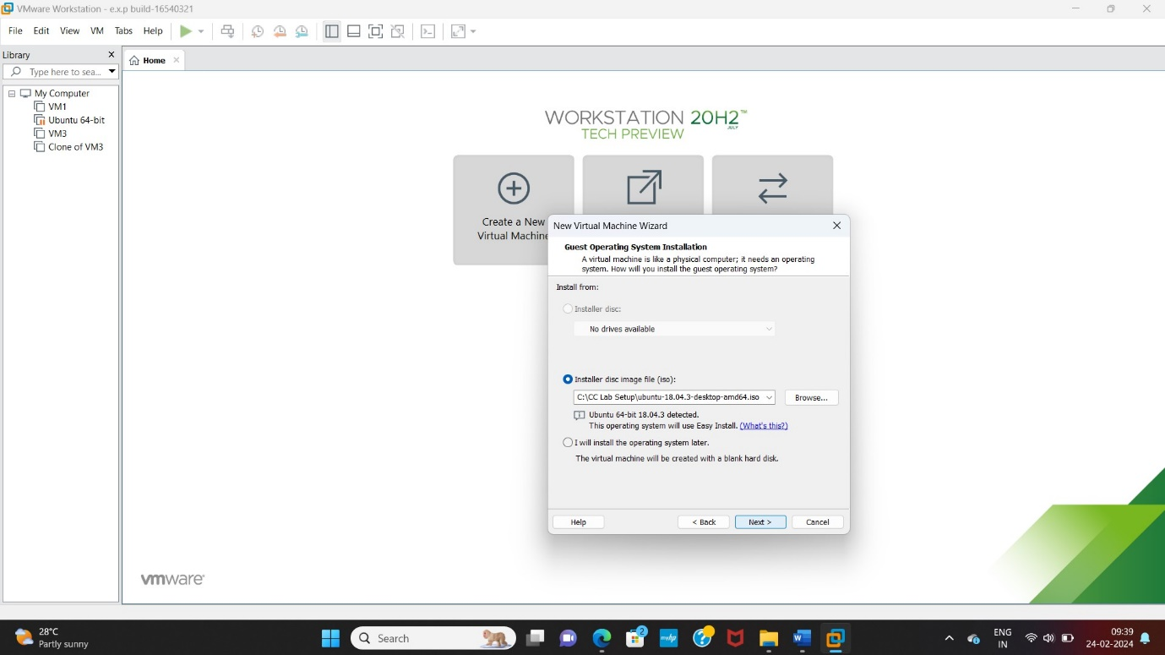

STEP 2:Create id and password

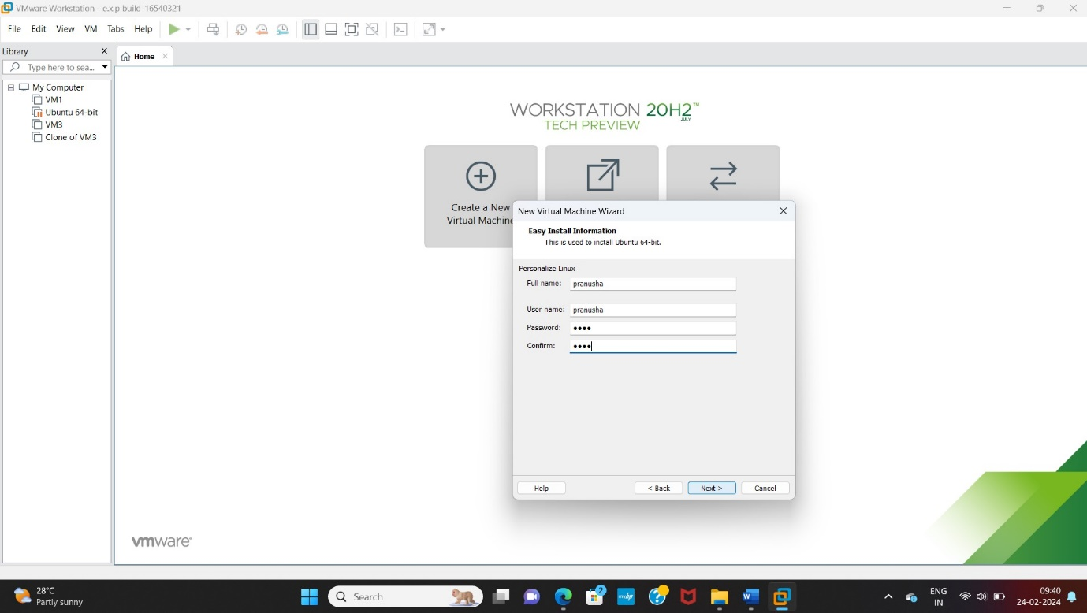

STEP 3: 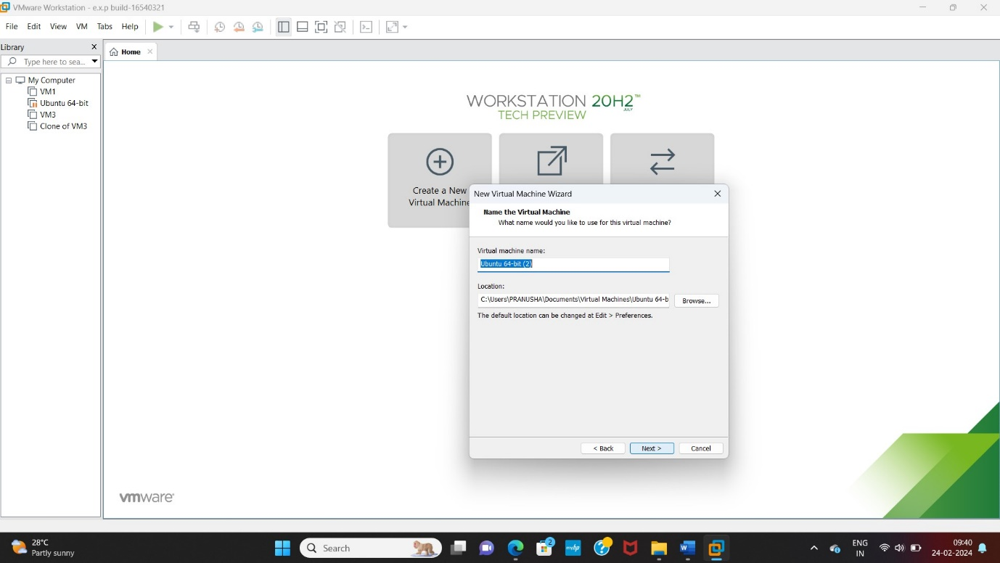

STEP 4:Add size 30 GB

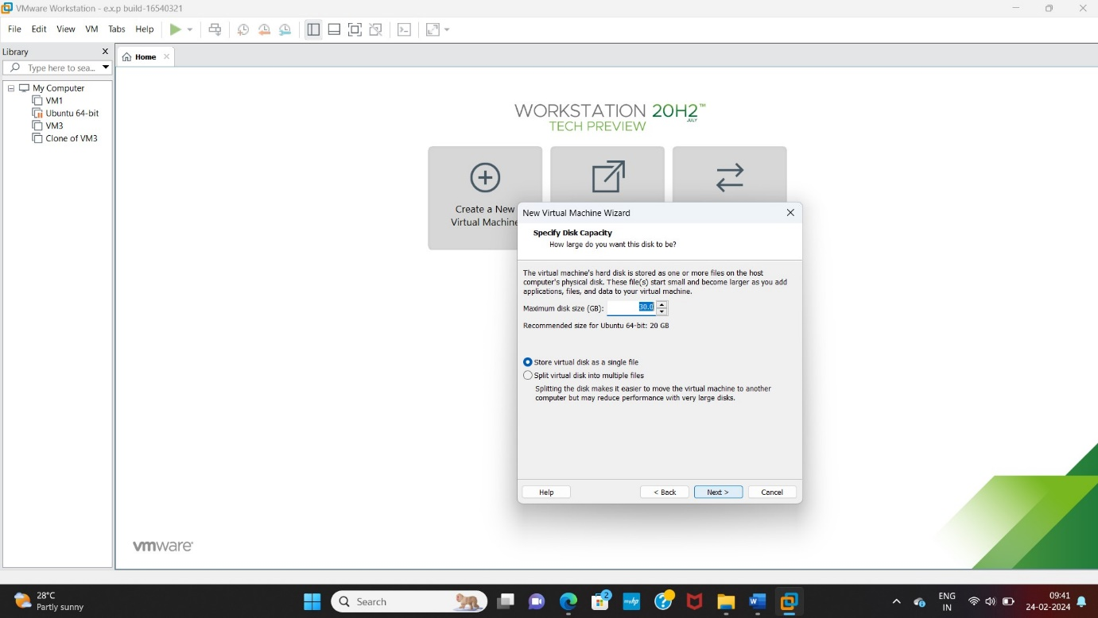

STEP 5:

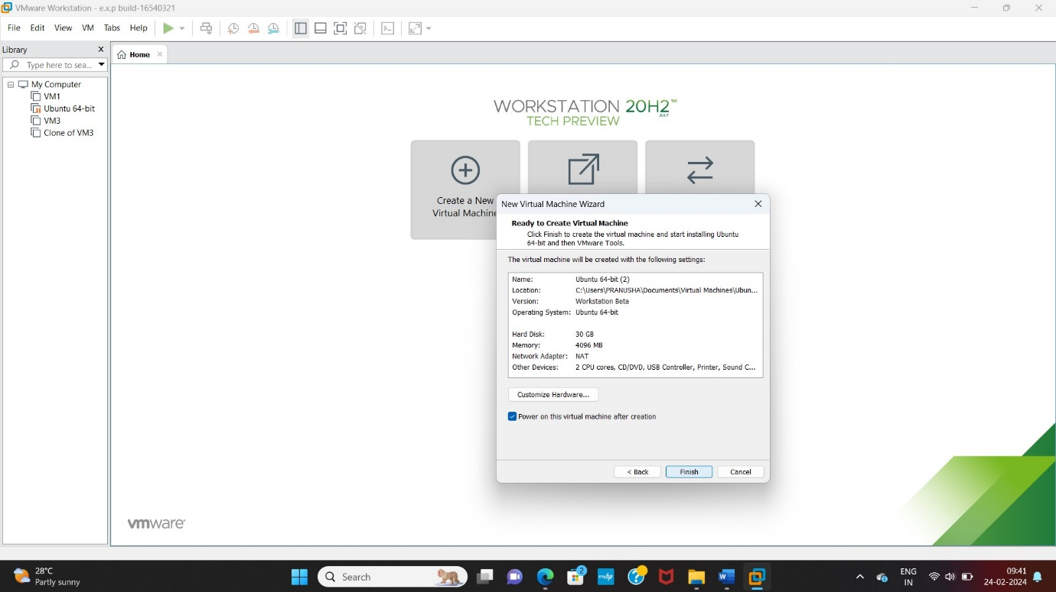

STEP 6:Run

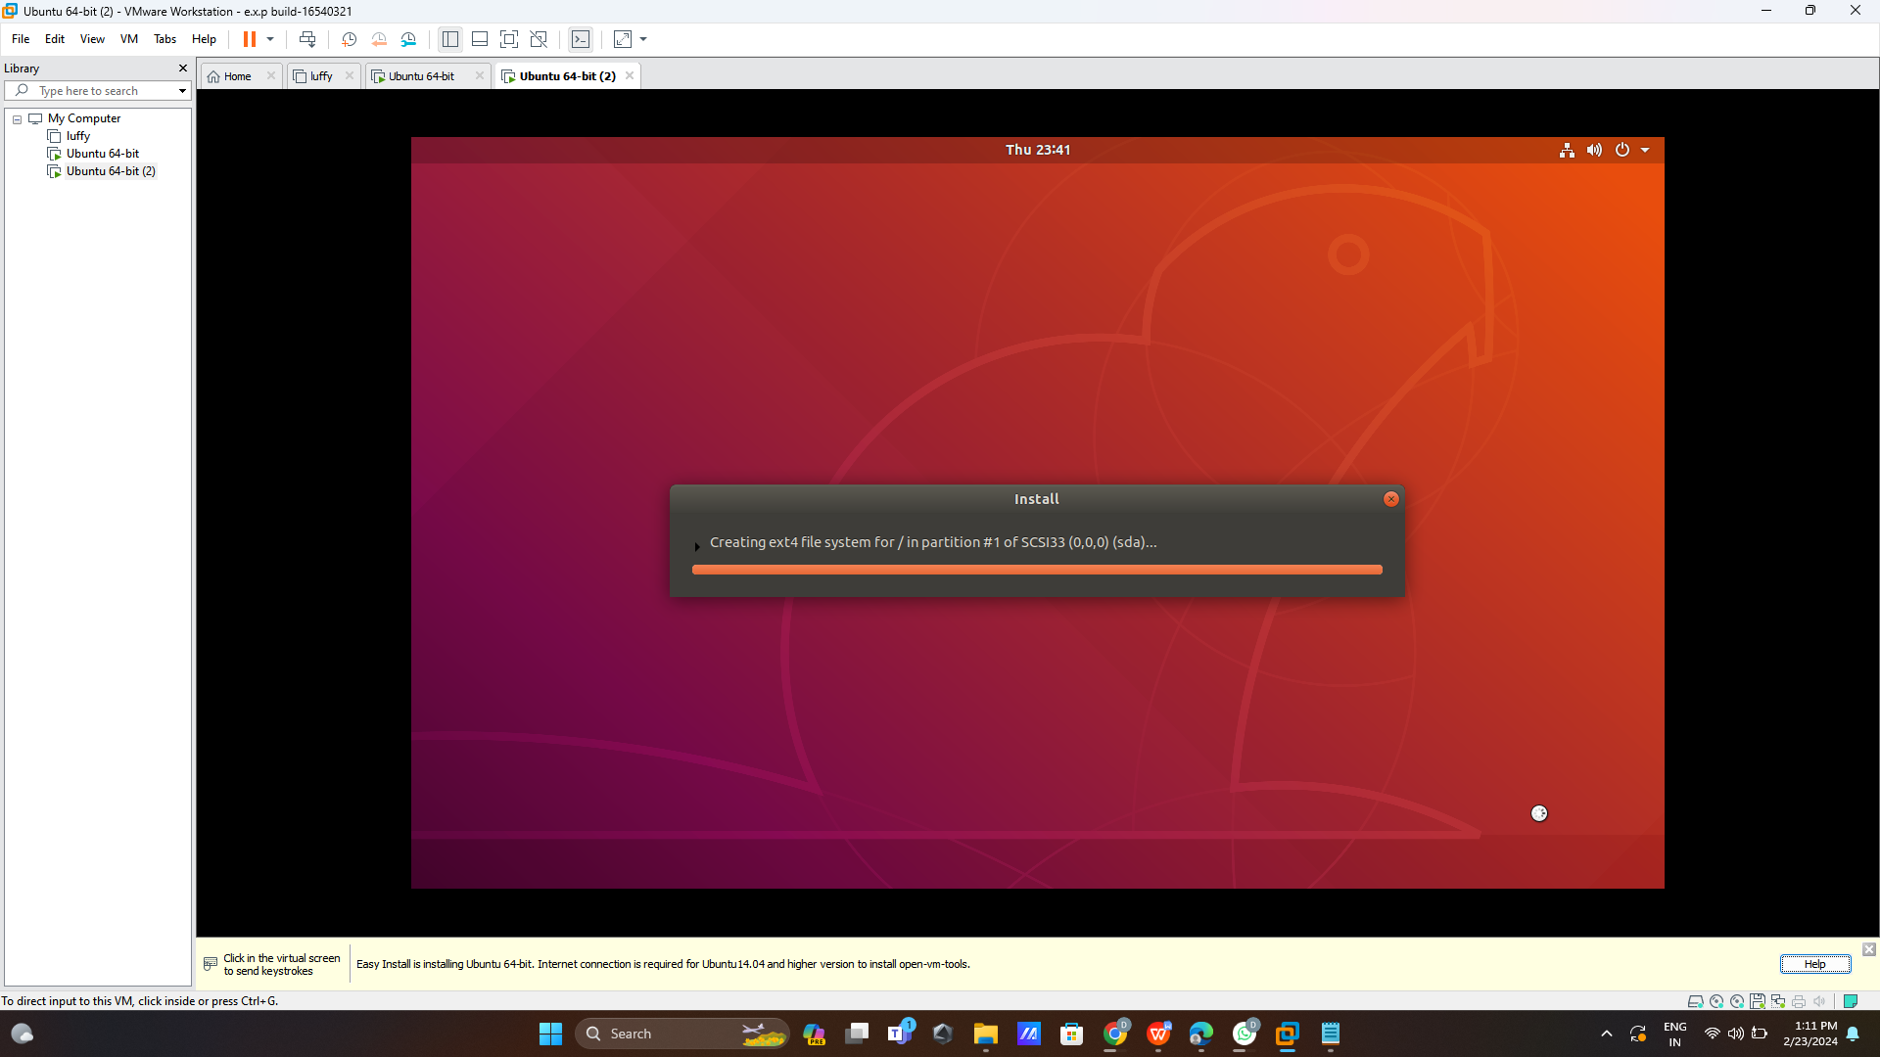

**Step 7:Login user id and open user page**

